**Downloading Free Microsoft Office at home for Staff and Students**

Students are now able to download the full latest version of Microsoft Office for **free on up to five devices** - PC or Mac or personal device. This is free of charge with their C2k username.



1. Visit <http://portal.office.com>
2. Login with your student username & password

<username>@c2ken.net ***Please note, use this format* <username>@c2ken.net**, ***NOT*** *@c2kni.net*.

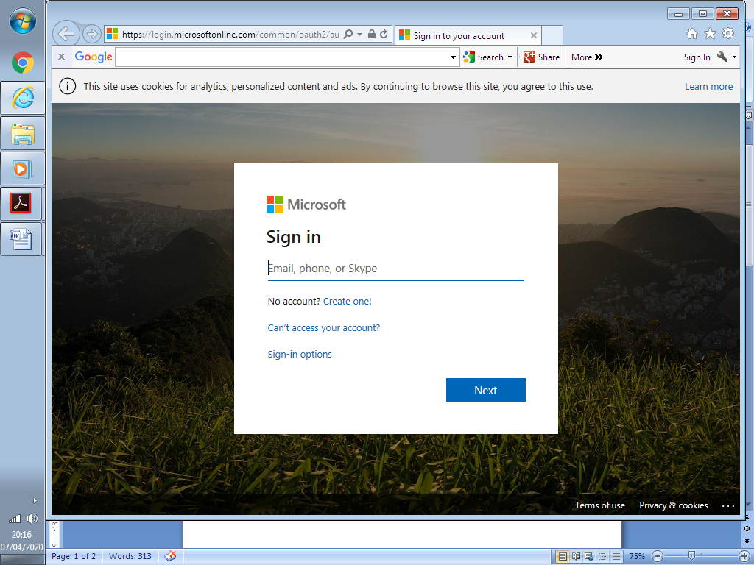

1. Login with only your username: jbloggs123 and password

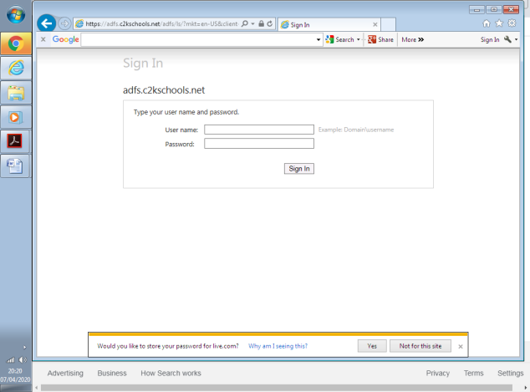

1. Click to stay signed in or not.

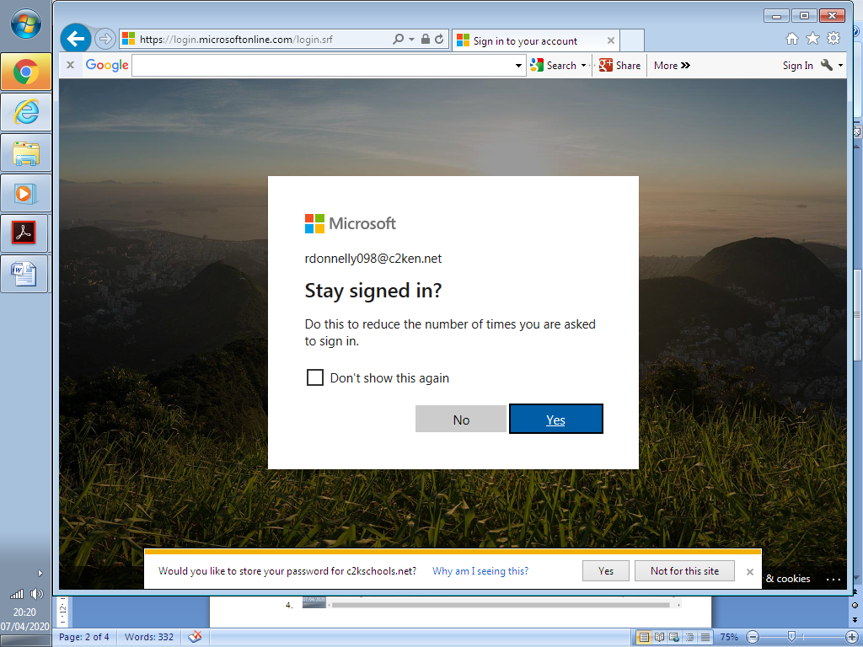

1. At the top right of the Microsoft Office 365 home screen, click the **Install Office** icon

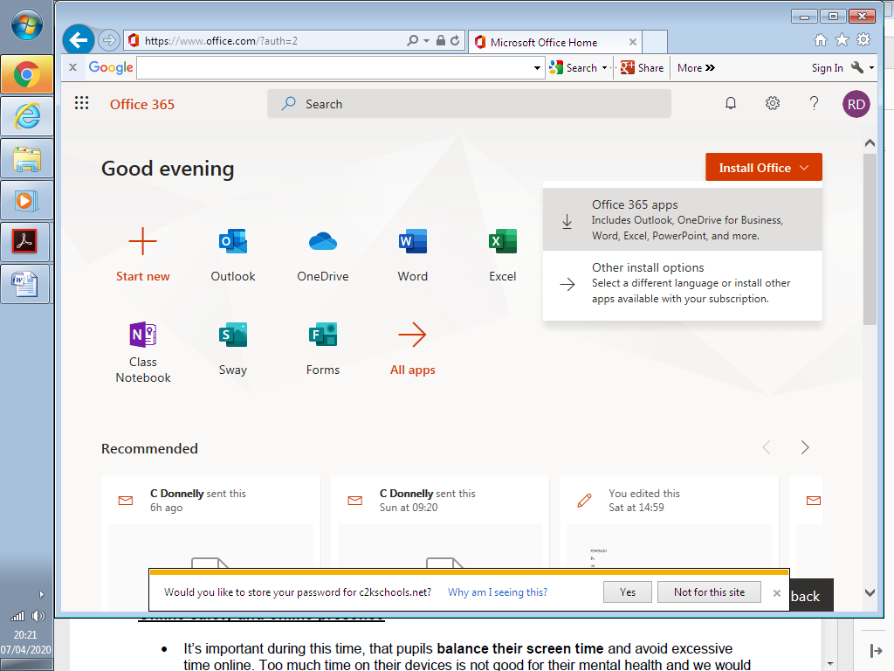

1. This launches the install advice screen. Select **Run** to continue from the option box that opens at the bottom of the screen.

Once you click **Run**, the installation of the full Office suite will start. As a large file (3Gb) installation can be slow.





When prompted to activate the software, enter your username in the format: <username>@c2ken.net ***Please note, use this format* <username>@c2ken.net**, ***NOT*** *@c2kni.net*.

Notes:

• The installation of Office will remain available while a student’s C2k username remains active. i.e. When a student leaves school, their C2k username will cease to be valid and will revert to a read-only version.

• Each user can install Office on up to 5 devices. These can be a combination of PC and Mac.

• Access to mobile applications on tablets and smartphones will require the same sign-in to activate all features and access all files and will count as one of your devices.

If a user installs Office on a 6th device, the software will remain as read-only until one of the previous 5 installations is deactivated. To deactivate an installation, go to the Office 365 settings page and select Software – Install and manage software and then follow the instructions.